Workflow extensions

# Introduction

The Workflow Extensions plugin contains several custom workflow actions. These allow users to create user forms much more easily and set workflow and entity attributes in single actions.

# Workflow Actions

After you have installed the Workflow Extensions plugin, you should now have the following workflow actions available under BEMA Services > Workflow Extensions:

## Attribute Values Set

The Attribute Values Set action uses an attribute matrix to set workflow values. For each row, you select the Workflow Attribute that you’re setting and then use either lava or another workflow attribute as the value you’re setting:

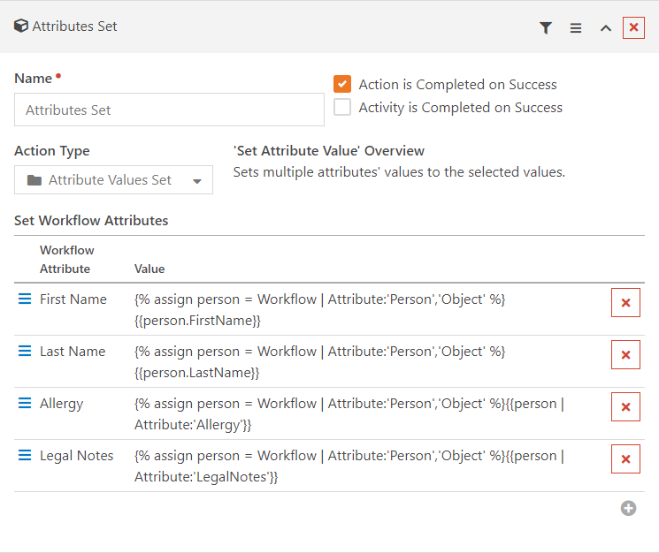

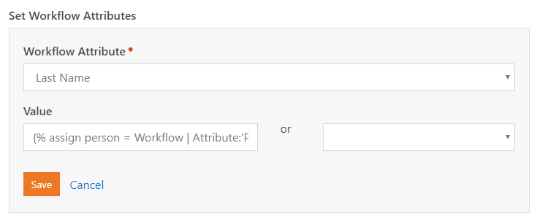

## Entity Properties Set

The Entity Properties Set action uses an attribute matrix to set entity properties. For each row, you select the Property that you’re setting and then use either lava or another workflow attribute as the value you’re setting:

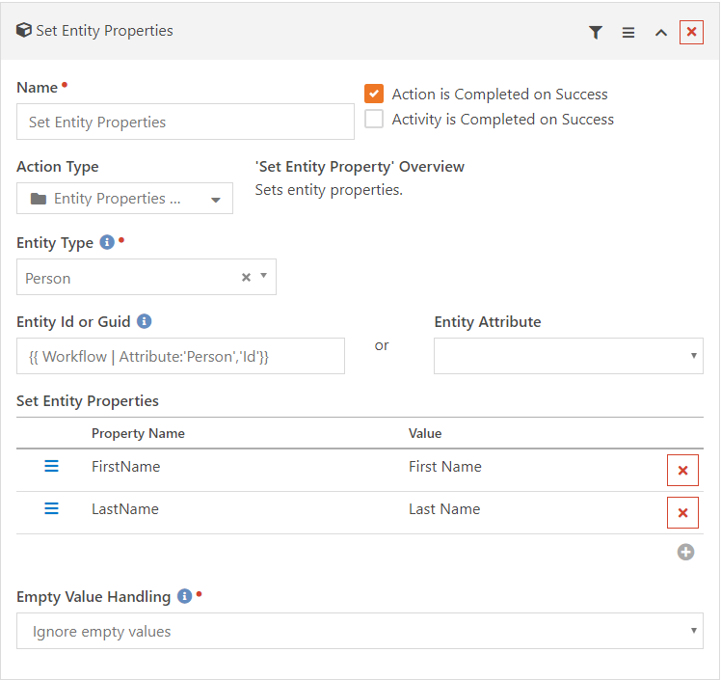  
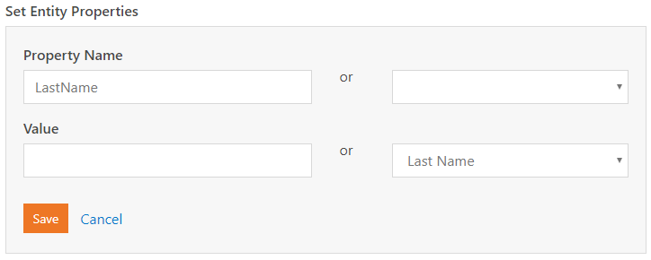

## Entity Attributes Set

The Entity Attributes Set action uses an attribute matrix to set entity attributes. For each row, you select the Property that you’re setting and then use either lava or another workflow attribute as the value you’re setting:

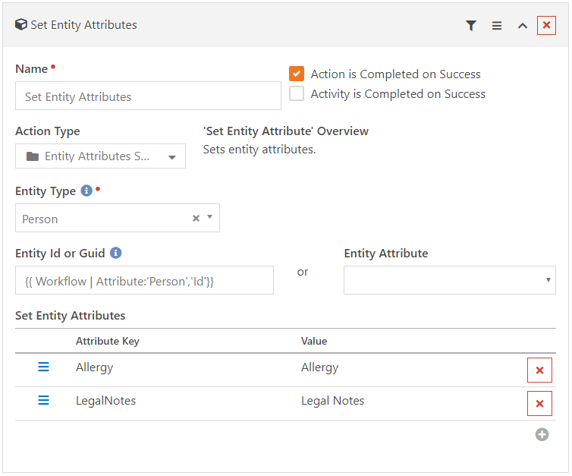  
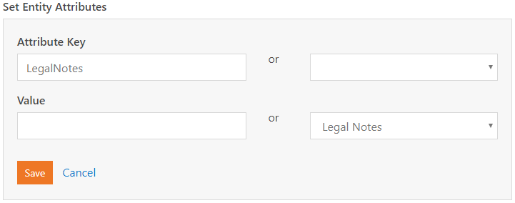

# Supporting Attribute Matrixes

The Workflow Extensions plugin uses several attribute matrixes, listed below.

